BIO ADSORBENT DERIVED NANOMATERIALS AND ITS SURFACE MODIFICATION FOR HEAVY METAL ADSORPTION

**Project report**

*under the supervision of*

**Prof. Gopal Das**

*for the degree of*

**Bachelor of Technology**

in

Chemical Science and Technology

By

**DEEPAK KUMAR MANDAL**

(Roll No. 170122014)



DEPARTMENT OF CHEMISTRY

INDIAN INSTITUTE OF TECHNOLOGY, GUWAHATI

April, 2021

Summary of BTP-I Thesis

|  |
| --- |
| **B**IO **A**DSORBENT **F**OR **E**NVIRONMENTAL **A**PPLICATIONS |

In the Project work on literature review on the ***“Bio Adsorbent for Environmental Applications”***, I had been studied on background of the field such as Different Types of Bio adsorbent, Advantages of Bio adsorbent in comparison to Chemical adsorbent. Further, the review is based on Recent Advances in the Technique and usage of Bio adsorbent for the adsorption of heavy metal ions and toxic dye molecules.

As we know, Heavy metals are a toxic pollutants that commonly present in aqueous solutions or wastewater through mining activities, pesticides, petroleum refinery, smelting, metal-manufacturing plants, battery manufacturing, painting and coating industries, volcanic emissions, deep-sea vents, etc. Another common pollutant is Dyes, which typically come from textile industries. Like heavy metals, dyes are also toxic, not bio-degradable; thus, are dangerous for the health of humans and the environment.

The Bio adsorption or Biosorption mechanism by adsorbent is usually complex and involves one or combinations of various different processes such as complexation, chelation, physical and chemical adsorption, electrostatic interaction, coordination, ion exchange, microprecipitation. We had considered the following bio adsorbent for the adsorption of toxic heavy metal ions, and toxic dyes.

**A modified activated carbon based bio adsorbent for the adsorption of toxic heavy metal ions:** The modified activated carbon-based bio adsorbent that is, **Fe3O4 NPs@AC@C4H8SO3H composites** could be synthesized; By Supporting Fe3O4 nano particles onto activated carbon - AC (which is produced from the agriculture wastes), we get the modified resulting surface which has a large numbers of active sites. Then, Fe3O4 nano-particle activated carbon could be separated by using the external magnet. Further, this is subjected to 1, 4 - butane sultone: -SO3H (which is a reagent and strong chelates or complexing agent) via ring-opening reaction, followed by sonication under mild condition (for enhancing the acidic functional groups on the Fe3O4 nano-particle activated carbon).

The major factor that causes the separation or adsorption of the heavy metals from aq. solutions is that; the heavy metal ions forms complex with the sulfonic acid (-SO3H), hydroxyl (-OH), and carboxyl (-CO2H) group presents on the surface of Fe3O4 NPs@AC@C4H8SO3H composites. The adsorption of toxic heavy metal ions on this nanocomposite bio-adsorbent depends upon various factor such as pH of the solution, Temperature, Dosage or amount of adsorbent, The initial concentration of the metal ions like As(III), Cd(II), Pb(II), Time of contact with adsorbent in the aqueous solution. The Recyclization process could be performed by just desorbing the metal ions from the adsorbent, thus posses reusability.

**Cellulose-keratin based bio adsorbent for the adsorption of toxic dye molecules from aqueous solution:** The Cellulose nano crystal reinforced keratin adsorbent is fabricated by adding Cellulose nano-crystal - CNC (which formed from the hydrolysis of cotton fabric) into Keratin solution (which is prepared from feathers via Extraction process); followed by the addition of crosslinking agent and freeze-dried process.

The separation of dye molecules from aqueous solution takes place due to the various interaction such as Formation of hydrogen bonds, Van der waals forces of interaction, Electrostatic force of interaction; between the dye molecule and the functional groups like amino (-NH2), hydroxyl (-OH), and carboxyl (-COOH) group presents in the cellulose nanocrystal-reinforced keratin bio adsorbent.

This fabricated bio adsorbent has large specific surface areas, enhanced mechanical property with high porosity, regeneration of adsorbent, thus provides good reusability, which shows excellent performance for adsorption of dye molecules.

***Usage:*** The modified bio adsorbent that is ***Fe3O4 NPs@AC@C4H8SO3H composites*** can be used for adsorption of heavy metal ions such as Lead: Pb(II), Cadmium: Cd(II), and Arsenic: As(III) from aqueous solutions at an industrial scale. & The ***Cellulose nano crystal reinforced keratin adsorbent*** is used for adsorption of dyes such as Reactive Black 5 (RB5), and Direct Red 80 (DR80) from aqueous solution or wastewater.

These biosorbent exhibits advantages such as green synthesis, high adsorption capacity, recyclization, low-cost, and more importantly easy separation with the technically feasible method. So, these bio adsorbents could be a suitable option for the adsorption of toxic heavy metal ions and toxic dyes. Thus, it is sustainable, renewal, and environmentally friendly alternative adsorbent for environmental applications.

|  |
| --- |
| **Work Done in BTP-II**  **B**IO **A**DSORBENT **D**ERIVED **N**ANO **M**ATERIALS **A**ND **I**TS **S**URFACE **M**ODIFICATION **F**OR **H**EAVY **M**ETAL **A**DSORPTION |

**Contents:**

1. A brief introduction to the “Bio Adsorbent Derived Nano Materials and its surface modification for Heavy Metals Adsorption” that are going to be present in the article.
2. Synthetic Procedure of different Bio adsorbent derived nano materials for heavy metal adsorption.

* Carbon Nano Tube (CNT)
* Carbon Nano Dot (CND)

1. Surface Modification of different nano materials for the adsorption of heavy metals

* Carbon Nano Tube (CNT)
* Carbon Nano Dot (CND)

1. Conclusion/Summary
2. References/Bibliography

**INTRODUCTION**

**Carbon Nano Tube (CNT)**

Carbon Nano Tubes (CNT) are the allotropes of sp2 hybridized carbon with a cylindrical nano-structure including six membered carbon rings.

There are following two major types of CNTs:-

1. Single-walled carbon nano tube (SWCNT)
2. Multi-walled carbon nano tube (MWCNT)

|  |
| --- |
| Figure 1: Types of Carbon Nanotube (CNT):- (a) Single-walled (SWCNT), and (b) Multi-walled (MWCNT) |

There are following difference between SWCNT and MWCNT [1]:-

1. The Single-walled carbon nanotubes or SWCNT contains one cylindrical graphene sheet. However, the multi-walled carbon nanotubes or MWCNT consists of several tubes in concentric cylinders of graphene sheets.
2. The diameter and length range of Single walled carbon nano tubes, SWCNT are usually greater than 1-2 nm, and 1 μm, respectively. However, The diameter and length range for multi walled carbon nano tube, MWCNT has over 1-50 nm, and 1 μm, respectively.

Carbon nano tubes-CNT shows excellent specific chemical, structural, mechanical, semiconductor, electronic, optical, thermal, and physical properties. Carbon nanotubes (CNT) seems to be an ideal adsorbents among the carbon nano-materials due to their light mass density, hollow structures, high specific surface area, tremendous reactivity, thermal resistance, acid and alkaline stability, excessive porous in nature, the strong interactions between CNTs and the adsorbate molecule such as heavy metal ions, etc., and unique physical & chemical properties[1].

Carbon Nanotubes have excellent adsorption capacity for removal of the toxic heavy metal ions from aqueous solutions or water, due to CNT has high surface-to-volume ratio as well as the well-arranged distribution of pore size. [**3**] The adsorption capacities of Carbon nano-tube depends upon the adsorbate and the functional groups on the surface.

**Carbon Nano Dots (CND)**

Carbon Nano Dot (CND) is a new type of carbon Nanomaterials which has sizes of below 10 nm with generally spherical shape. In 2004, Carbon Nano Dot or CND was first obtained in during the purification of Single walled carbon nanotube, (SWCNT) through the preparative electrophoresis [**2**]. CNDs is abundant, benign, and inexpensive nature. Carbon nanodots (CNDs) are also known as Carbon dots (CDs), carbon quantum dots (QDs), or fluorescent carbon nano-particles (CNPs) [**3**]. Carbon nano dots are composed of both sp2 and sp3 hybrid carbon networks [**4**].

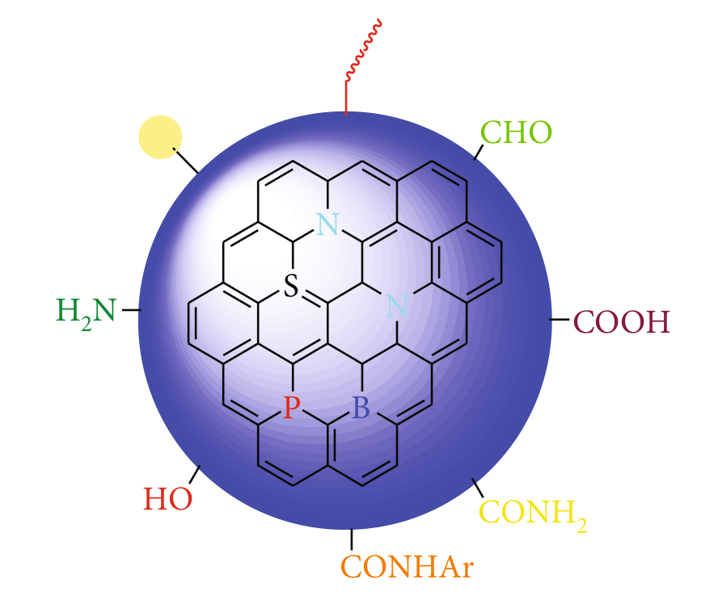

*Figure 2: A* generalized structure of Carbon Nano-dots (CND)

**SYNTHETIC PROCEDURE OF DIFFERENT NANOMATERIALS**

**2.1 Carbon Nano Tube (CNT) as a Bio adsorbent derived nanomaterials for heavy metal adsorption.**

Carbon nanotubes can be synthesized by various methods as following. However, In general CNTs is made up of cylindrical sheets of graphite, rolled into tube. So it is essentially the allotropic forms of carbon [**13**].

***Arc-discharge method*** [**11**]:

The Single-walled carbon nanotubes (SWCNT) are synthesized by the direct current (d.c.) Arc discharge method. In this process, The Graphite rod which is spectroscopy pure, with a hole drilled and then filled with powder mixtures of calcium carbide and nickel (CaC2/Ni) or Y-Ni alloy, is used as an anode. The graphite in metal/C atomic ratio is of 3-10. An Arc is generated between the sharp top of graphite cathode and the anode at 500-700 torr static atmosphere of helium (He). A certain gap is maintained between the electrodes by translating the anode all over the arc process.

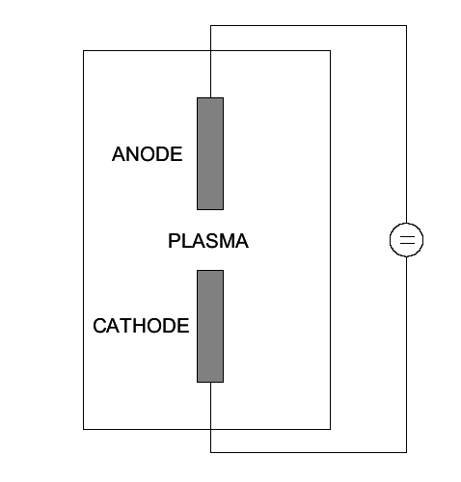

*Figure 3: Setup for Arc-discharge technique*

A setup shown above in figure 3 is for Arc discharge technique, which basically involves the growth of Carbon nanotubes - CNT on carbon(graphite) electrode during the d.c. arc discharge evaporation of carbons in presence of the inert gas, like argon (Ag), or helium (He) [**6**].

***Laser-ablation*** [**6**] : The CNT was first synthesized using the laser-ablation technique by Guo et al. In 1995. The single-walled carbon nanotubes can be synthesized by laser vaporization of the mixtures of carbon (graphite) and transition metal as a catalyst, located on the target.

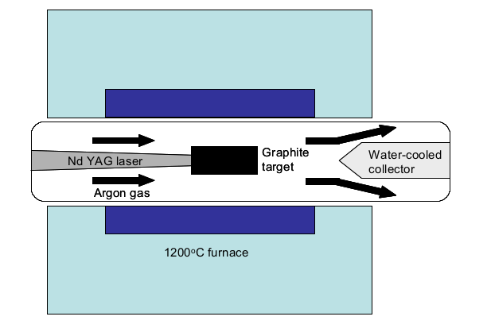

*Figure 4: A schematic diagram of Laser-ablation apparatus*

A laser (pulsed) is used to vaporized the target consists of mixtures of graphite and metal catalysts like nickel (Ni) or cobalt (Co) in the presence of helium (He) or argon (Ar) gas of 500 Torr pressure at 1200 oC furnace temperature.

*Mechanism*: Now as the target is vaporized, a clouds of C, C2, C3, and catalyst vapour is being formed very quickly. As the cloud becomes cool, the carbon species with small molecular weight then combines to form large molecules. The vaporized catalyst condenses at a slow rate and sticks fast to carbon cluster to prevent their closing into cage-like structures. The growth of this molecule continues to form Single-walled carbon nanotubes or SWCNT until either the catalyst clusters are getting too larger or until the condition have been cooled.

**2.2 Carbon Nano DOT (CND) as a Bio adsorbent derived nano materials for heavy metal adsorption.**

The Synthetic methods for Carbon Nano Dots (CND) with tunable size could be generally classified into the following two main groups [**2**]:-

1. Chemical methods that includes electrochemical synthesis, Thermal, Hydrothermal, Combustion, acidic oxidation, Microwave or ultrasonic, supported synthesis, cage-opening of fullerene, solution chemistry methods, etc.
2. Physical methods which includes Arc discharge, Plasma treatment, Laser ablation or passivation, etc.

|  |
| --- |
| *Scheme 1: Representation of the synthesis methods for CD or CND[****12****]* |

***Hydrothermal Method:-*** Hydrothermal method for the synthesis of Carbon Nanodots is the most favorable method, due to their several advantages such as non-toxic, low cost or cost-effectiveness, eco-friendly, and easy operational technique.

In the Hydrothermal method or technique, a solution of organic precursors is sealed in a hydrothermal synthetic reactor where chemical reaction occurs at high temperature and pressure [**4**] . This process is referred to as **Hydrothermal**, because in this method water is used as the solvent. The same synthesis method except the organic solvent is used instead of water solvent, then this modified process is termed as **Solvothermal synthesis method** [**9**].

|  |
| --- |
| *Figure 5: Synthesis of Carbon Nano Dots or CDs from the sweet potato via hydro-thermal technique.* |

*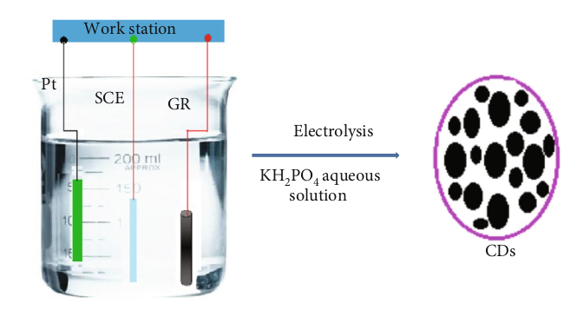****Electrochemical Method:*** An ultra-pure carbon nanodots can be synthesized by Electrochemical methods, from molecular matter such as graphite, carbon-fiber, or carbon nanotube through electrolytic process. In this technique, the large organic molecule are used as an electrode with the presence of suitable electrolytes.

|  |
| --- |
| *Figure 6: A pictorial representation for the synthesis of Carbon Nanodots by electrochemical method* |

***Pyrolysis Method:*** In this method, Carbon nanodots is synthesized from organic compound at high temperature, by simple chemical reactions takes place in presence of strong basic or acidic condition. Example:- Synthesis of CND for hair (keratin) using pyrolysis method for 24 hours of reactions time at 473K.

|  |
| --- |
| *Figure 7: Synthesis of CND by Pyrolysis method* |

**Carbon Nanodots derived from tapioca, i.e; a bio adsorbent derived nanomaterials for the adsorption of heavy metal ion from aqueous solution.**

***Synthesis:*** The Tapioca flour is basically a starch which has extracted from storage root of cassava plants, is used in the synthesis of fluorescent carbon-dots or carbon nanodot through Hydrothermal method. Further, it is used for the adsorption of toxic heavy metal ions such as Lead, Pb(II). [**5**]

Acetone ((CH3)2CO), Sodium hydroxide (NaOH), Tapioca, Hydrothermal reactor, lead (II) nitrate (Pb(NO3)2). The Solution that is used was prepared with deionized water (D.I H2O).

***There are the following steps involved during the synthesis of Carbon Nanodots:-***

1. Tapioca flour is mixed with D.I H2O/ (CH3)2CO/ NaOH as a solvent. Further, the mixture is subjected to an oven for heating at around 175 °C, which leads to the formation of glucose and disaccharide.
2. Polysaccharides is formed by the crosslinking of disaccharide with several other disaccharide. However, The desired product i.e.; Carbon nano-dots or CDs is produced through the carbonization of Glucose. The synthesized Carbon nanodots has the functional groups such as COO-, CH, C=O, C=C, -OH, C-O-C afloat on the surface.

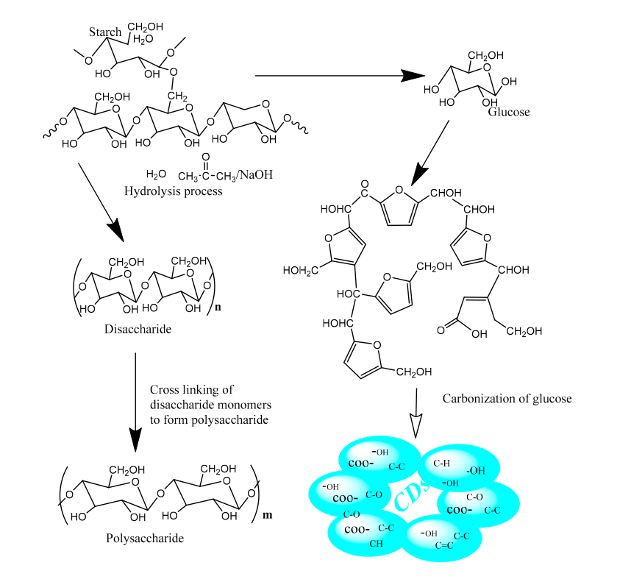

*Scheme 2: Mechanism for the synthesis of Carbon nano dots or CDs*

***Fourier Transform Infrared spectroscopy (FT-IR):*** Carbon nano-dots is characterised by the help of Fourier-Transform Infrared spectroscopy (FT-IR), which allows for direct measurement or identification of the functional groups that present in carbon nanodots, CDs.

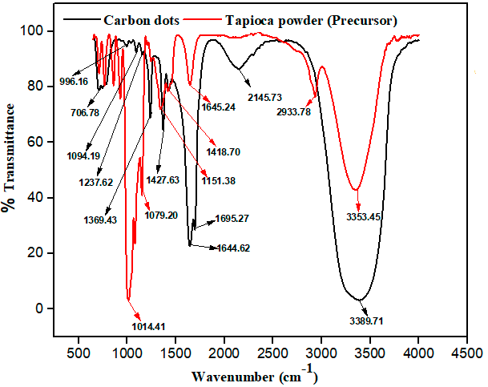

*Figure 8: FT-IR spectrum for the starting material (tapioca) and Carbon Nano-dots (CND)*

The Fourier Transform Infrared spectroscopy (FT-IR) graph of before ( i.e; tapioca flour) and after (i.e; carbon nano-dot) hydro-thermal treatment of the precursor of carbon materials is shown as below in Figure 6. Here, The Frequency range is 4000-500 cm-1, and from the figure 8, we can see that the peeks associated with stretching vibrations of the following:

Table 1: Stretching vibrations peeks of various functional group

|  |  |
| --- | --- |
| **Functional groups in *tapioca powder*** | **Recorded stretching vibration in FT-IR graph** |
| Carboxylic (COO-) | 2933.78 cm-1 |
| Hydroxyl (-OH) | 3353.45 cm-1 |
| Bending modes of sp2 and sp3 -CH group | 1151.38 cm-1, 1079.20 cm-1, 1014.41 cm-1 |

|  |  |
| --- | --- |
| **Functional groups *in CND*** | **Recorded stretching vibration in FT-IR graph** |
| Carboxylic (COO-) | 2145.73 cm-1 |
| Hydroxyl (-OH) | 3389.71 cm-1 |
| Bending modes of sp2 and sp3 -CH group | 1695.27, 1644.62 cm-1 |
| C-O-C | 1427.63 cm-1 to 1369.43 cm-1 |
| C=C | 1237.62 cm-1 |
| C=O | 1094.19 cm-1 , 996.19 cm-1 |
| C=C bound of unsaturated glucose structure | 706.78 cm-1 |

***Atomic Force Microscopy (AFM)***

By using the Atomic Force Mircoscopy - AFM technique, we can determine the particle size of Carbon nanodots that has synthesized. It is very important for the measurement of size of the particle of nanomaterials with a very high precision of nanometer scale range.

Carbon Nanodots derived from tapioca is used for the adsorption of heavy metal ion such as Lead (II) from aqueous solution.

**SURFACE MODIFICATION OF DIFFERENT NANOMATERIALS**

***3.1 Surface modification of Carbon Nano Tube (CNT) for the adsorption of heavy metals.***

The adsorption of heavy metal ions behavior by carbon nanotube depends on various factor such as functional groups, site density, porosity, purity, types of CNT, and surface area.

***Surface modification:*** There are various methods by which the surface modification of carbon nanotubes could take place, and further it can be used for the adsorption of toxic heavy metal ions. The few examples is summarized in Scheme 3 as shown below:

|  |
| --- |
| *Scheme 3: A schematic diagram for various surface modification on Carbon Nano Tubes (CNT) [****7****]* |

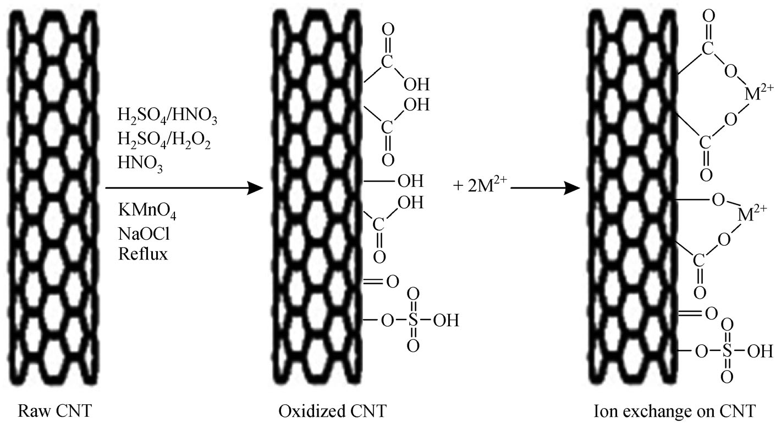

*Scheme 4: Generalized mechanism for acid modification of CNTs and adsorption metal ions.*

**Mechanism:** The surface modification of Carbon Nanotubes or CNT using various acids as a reagents, and their mechanism for the adsorption metal ions which are divalent (M2+) in nature, on modified CNT’s surface are given in Scheme 5.

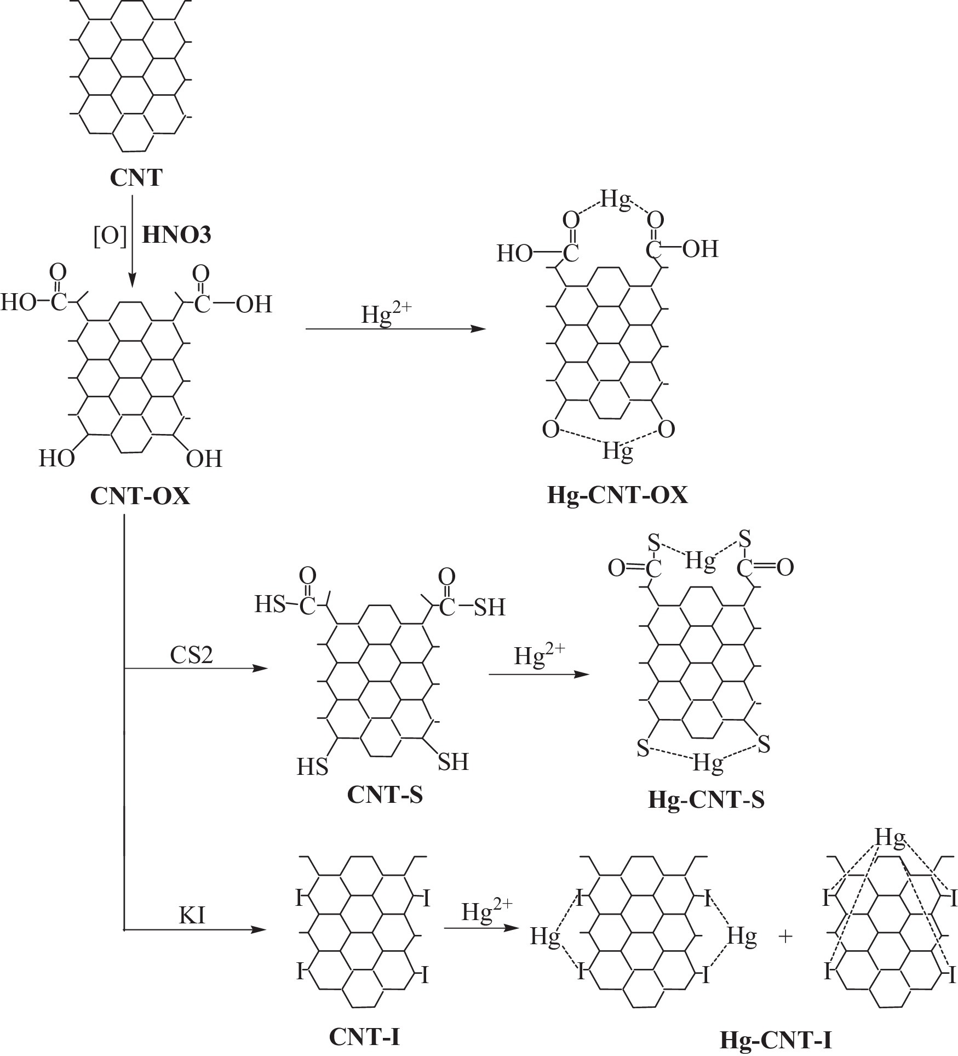

*Scheme 5: Reaction mechanism for surface modification and adsorption of heavy metal ions such as Hg(II) in case of Carbon nanotubes*

In the Oxidized Carbon Nanotubes (CNT-OX), Iodide incorporated carbon nanotube (CNT-I), and sulfur incorporated carbon Nanotubes (CNT-S), adsorption of heavy metal ions occurs because of the bounding between the Mercury: Hg(II) metal ions and various functional group such as carboxyl (-COOH), hydroxyl (-OH), and sulfur ligands (-SH) [**10**].

***Effect of pH:*** The adsorption of heavy metal ions on the modified carbon nanotubes surface increases by increasing the solution pH. Here, As we are increasing the pH of the solution, the surface charge of modified CNT becomes negative (since the basic character will be increasing) then an electrostatic force of attraction takes place between the positively charged metal ions and negatively charged CNT surface.

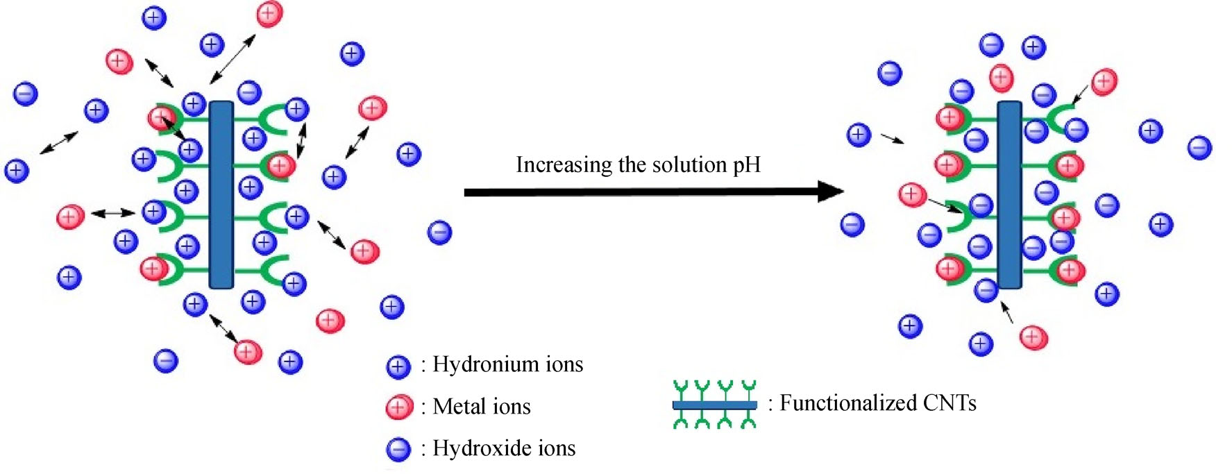

*Scheme 6: Mechanism for heavy metal ions adsorption by increasing the pH of the solution.*

This modified adsorbent such as Oxidized Carbon Nanotubes(CNT-OX), Iodide incorporated carbon nanotube (CNT-I), and sulfur incorporated carbon Nanotubes: CNT-S is used for the adsorption of heavy metal ions such as Mercury (Hg2+).

**3.2 Surface modification of Carbon Nano DOT (CND) for the adsorption of heavy metals.**

Generally, the Carbon Nano Dots are obtained from different carbon resource such as Carbon nanotubes, carbon rods, graphite powder, carbon fiber, etc. via oxide-cutting. These carbon material exhibits perfect sp2 carbon structures. The most efficient method is cutting with acid oxidizing (concentrated) H2SO4/HNO3 mixtures or Conc. HNO3. The entire process could be divided into two parts:- **[**14**]**

1. At first, the bulk carbon material has been cut into small-small pieces.
2. And then the surface is modified by oxygen based group.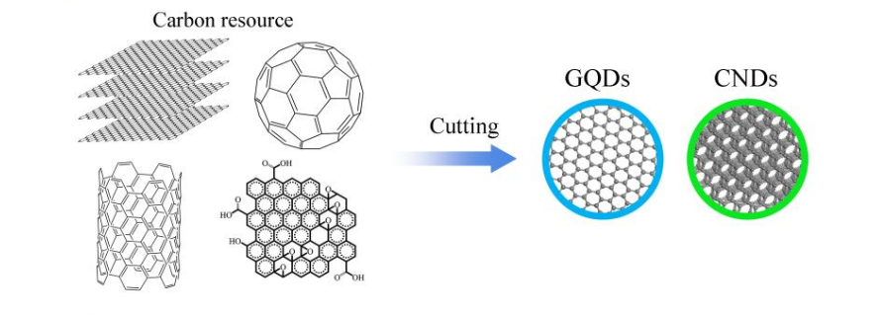

Scheme 7: Cutting of several carbon sources to get CND (Top-down)

The produced small carbon products is so called carbon nano dots (CND), graphene quantum dots(GQD), or carbon quantum dots (CQD).

**Now, Let’s consider a Green synthesis preparation method for Fe3O4@C-nanodot@GO hybrid materials** **[**15**]**

There are following steps involved in the synthesis and surface modification of magnetic carbon nano dot adsorbent:-

* Graphene oxide (GO) is prepared from the graphite powder via modified Hummer technique/method.
* Cow’s milk is used in the production of Carbon nano dots (C-nanodots). And for the synthesis of Carbon nano dots, the de-ionized pure water is added into the milk and further resulting mixture is subjected to hydro-thermal synthesis unit (hydro-thermal synthesis reactor), then it is washed and dried to get the C-nanodot.
* Hydro-thermal synthesis technique which is a cheap and easy nano-materials production method is used to synthesized the adsorbent i.e.; Fe3O4@C-nanodot@GO hybrid materials. So, for the same FeCl3 and sodium acetate (CH3COONa) is dissolved in ethylene glycol ((CH2OH)2), and Graphene oxide(GO) and C-nanodot (previously produced) is added to the resulting solution. Here we have used utlrasonic vibration for the homogeneous distribution of GO and C-nanodot into the whole solution.
* 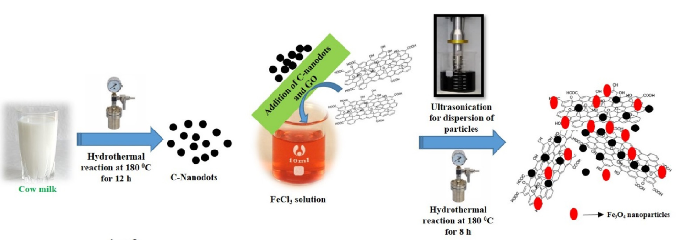Further it is subjected to hydro-thermal synthesis reactor, and finally a magnet is used to separate the Fe3O4@C-nanodots@GO particle from the liquid phase solutions. Then it is washed, and dried in oven, thus the desired magnetic Fe3O4@C-nanodot@GO hybrid materials as an adsorbent has been obtained.

Scheme 8: Synthesis procedure for the surface modification of carbon nano dots

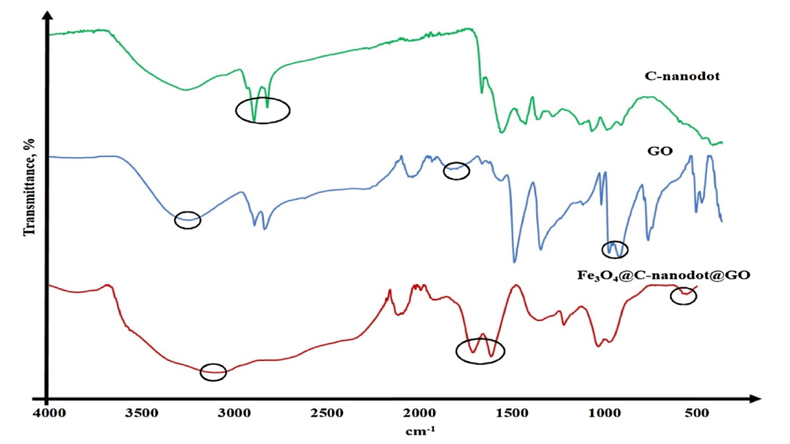From the figure 9, for the Fe3O4@Carbon-nanodots@GO adsorbent’s FT-IR spectrum, we have specific adsorption peak at around 3240 cm-1 is belongs to O-H stretching vibration. The peeks at around 1700cm-1 , 1550 cm-1 belong to the C=O and C=C respectively of Graphene oxide is still dominant. The specific peaks of Fe-O stretching vibrations is obtained at around 520 cm-1 . Hence, These peeks for modified adsorbent confirms that Fe3O4  nano-particles and Carbon nano dots(C-nanodots) has been successfully formed on the various region of graphene oxide (GO).

Figure 9: FT-IR spectrum for Fe3O4@Carbon-nanodots@GO adsorbent, Graphene oxide, and Carbon nano dot

The separation of Heavy metals from aqueous solution could take place due to the interaction between the metal ions and the functional groups such as hydroxyl (-OH), carboxyl (-COOH) present on surface of the Fe3O4@Carbon-nanodots@Graphene-oxide adsorbent. This adsorbent have advantage of Fe3O4 so it contains huge number of active sites or functional group contained oxygen atom, which plays an important role for the adsorption of heavy metal ions. Because it could form complex with Metal ions.

**C**ONCLUSION

In this article, I have been worked on the Synthesis procedure of different biosorbent derived nanomaterials such as Carbon nanotube & Carbon nanodots and, their surface modification for adsorption of heavy metal ions. The modified Carbon nanotubes such as CNT-S, CNT-OX, and CNT-I are used for removal of Mercury(II) metals. Although CNTs is of high costs, But it still may be favorable because of its high adsorption capacities, and this will reduce its high price. Carbon nanotubes could be also cost effective or cost could be reduced, because of its frequent accessibility and recyclization or regeneration. Carbon Nanodots (CND) which is derived from tapioca plant is used for the adsorption of Lead(II) metal ions from aqueous solution. Carbon nano dots has advantages such as low toxicity, Inert chemicals, and simple functionalization. A modified magnetic carbon nano dots as an adsorbent, i.e.; the “Fe3O4@C-nanodot@GO hybrid materials” is synthesized using green synthesis approach and further it could be used for heavy metals adsorption.

**R**EFERENCES

1. A review article on Carbon Nano-Tube for removal of heavy metals from wastewater; 2019. DOI: <https://doi.org/10.1007/s11705-018-1765-0>

2. A review article on Carbon Nano-Dot: synthesis, properties and applications; 2012. DOI: 10.1039/c2jm34690g

3. Carbon dots based luminescent assays for the analysis of inorganic trace, 2015. DOI: [10.1515/revac-2015-0003](https://sci-hub.se/10.1515/revac-2015-0003)

4. A review article on Nanoscience: Carbon Dots, 2019. DOI: <https://doi.org/10.1155/2019/3451307>

5. Fluorescent carbon dot as a eco-friendly sustainable nanomaterial, for heavy metal ions adsorption from aqueous solutions, 2019. DOI: 10.3390/nano10020315

6. A review on the synthesis of Carbon nanotubes, 2005. DOI: <https://sci-hub.se/10.2202/1542-6580.1279>

7. An article on Carbon Nanomaterials synthesis, surface modification, properties using the Biomass as a starting materials. 2020. DOI: 10.3390/ma13183945

8. Carbon nanotubes as an adsorbent for environmental pollution management, 2011. DOI: <https://sci-hub.se/10.1016/j.cej.2010.08.045>

9. Synthesis of Nano-particles via Hydrothermal or solvothermal method, 2016. DOI: [10.1007/978-3-319-15338-4_17](https://sci-hub.se/10.1007/978-3-319-15338-4_17)

10. Adsorption enhancement of mercury, using multiwalled carbon nanotubes, 2014 DOI: <https://sci-hub.se/10.1016/j.jhazmat.2014.03.020>

11. Single wall CNT synthesis by arc-discharge at large scale, DOI: <https://sci-hub.se/10.1016/S0022-3697(99)00358-3>

12. A review on Carbon Nanodots in aspects of current fundamental understanding, 2018.

DOI: <https://doi.org/10.3390/c4040067>

13. Oxidized carbon nanotube for removal of Cd(II) and endrin from wastewater, 2009 DOI: <https://sci-hub.se/10.1002/jctb.2035>

14. Current state and future perspective of carbon nanodots, graphene quantum dots, and polymer dots and their photo-luminescence mechanisms. 2014. DOI: 10.1007/s12274-014-0644-3

15. A Green Synthesis of the magnetic carbon nano dots or Fe3O4@Carbon nano dot on graphene oxide hybrid materials as an adsorbent. 2019. DOI: https://doi.org/10.1016/j.jpba.2019.113001